Guide to deploy a Nancy API on Ubuntu

## Install mono on your Ubuntu machine

$ Sudo apt-get install mono-complete



## Create Host Server

* 1. Using Visual studio, Create a Host server in the form of a console application Project
  2. Install following Nuget Packages:

Install-Package Nancy.Hosting.Self

Install-Package Mono.Posix

* 1. Edit the Program.cs as following:

using Mono.Unix;

using Mono.Unix.Native;

using Nancy.Hosting.Self;

using System;

namespace NancyDemo

{

class Program

{

static void Main(string[] args)

{

var uri = "http://localhost:8888";

Console.WriteLine("Starting Nancy on " + uri);

// initialize an instance of NancyHost

var host = new NancyHost(new Uri(uri));

host.Start(); // start hosting

// check if we're running on mono

if (Type.GetType("Mono.Runtime") != null)

{

// on mono, processes will usually run as daemons - this allows you to listen

// for termination signals (ctrl+c, shutdown, etc) and finalize correctly

UnixSignal.WaitAny(new[] {

new UnixSignal(Signum.SIGINT),

new UnixSignal(Signum.SIGTERM),

new UnixSignal(Signum.SIGQUIT),

new UnixSignal(Signum.SIGHUP)

});

}

else

{

Console.ReadLine();

}

Console.WriteLine("Stopping Nancy");

host.Stop(); // stop hosting

}

}

}

## Code the Nancy API Module

* 1. In the same solution, add a new module as a class file *HelloModule.cs*
  2. Edit the class file to have a basic *Get* method as following:

using Nancy;

namespace NancyDemo

{

public class HelloModule : NancyModule

{

public HelloModule()

{

Get["/"] = parameters => "Hello World!";

}

}

}

## Test it locally

* 1. Once the API module is created, run the self host (console) exe.
  2. In the browser, run the <http://localhost:8888> – Hello World shall show up in browser

## Install Apache on Ubuntu Server

* 1. sudo apt-get install apache2



* 1. Type <http://localhost> in firefox browser, welcome page for Apache shall appear.

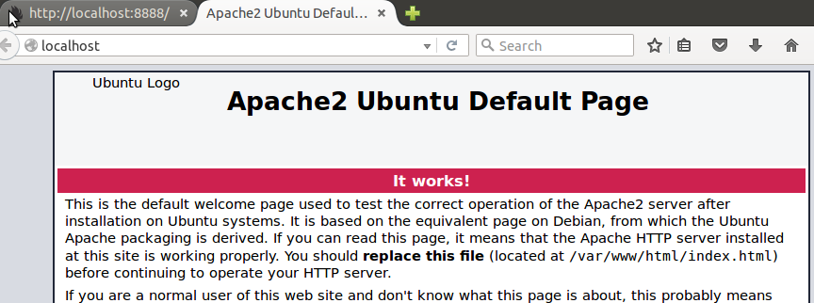

## Migrate the API code to Ubuntu server

* Copy the complete set of API and console code to Ubuntu server
* Create following folder:

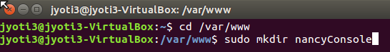

* Ensure that your code is copied to location /var/www/nancyConsole folder



## Configure Apache for hosting API code

* 1. on the command prompt, open text editor gedit



* 1. in the text editor, type as following:

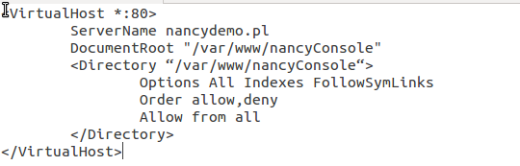

In case of nginx, the file should look like following:

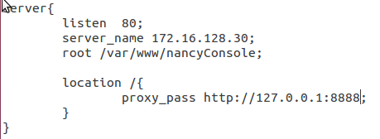

* 1. save the file as nancydemo.conf at location shown below:

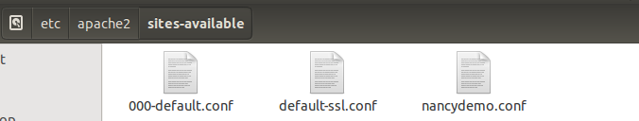  
*in case of nginx, location should be etc\nginx\sites-available*

* 1. enable the site by typing following command:

$ sudo ln -s /etc/apache2/sites-available/nancydemo /etc/apache2/sites-enabled/nancydemo

* 1. Restart the Apache server to reload the settings:



## Install Supervisor

In order to let the Host console run independently, install the supervisor on Ubuntu server as following:



## Configure and Run the Supervisor

* 1. Run the gedit and create a new file */etc/supervisor/conf.d/NancyConsole.conf*
  2. Edit the file as followings:

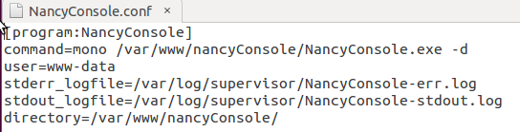

* 1. On the $ prompt, start the supervisor service



* 1. Enter the Supervisor control



If the NancyConsole process is not already listed as ‘running’, then use following steps:

* + 1. 
    2. 

## Test in Browser

On Ubuntu server, in firefox browser, type <http://localhost:8888> OR <http://nancydemo.pl:8888>, you shall see “hello world” message:

